**Final Project – Olde Worlde Phunne Maze Game**

**Day 1:**

The first thing I did on day 1 was to read the project outline documentation. Following this I put together the word documents I needed, including the requirements specification, the test plan and the UI mockups. I then created a git repository in my company’s source control server.

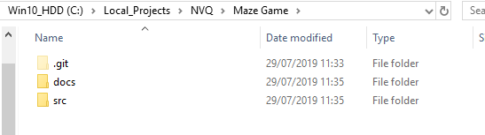

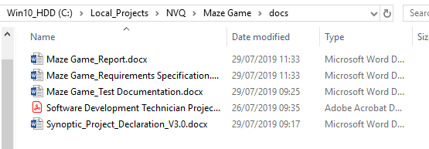

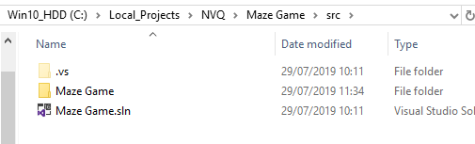

**Future Improvements:**